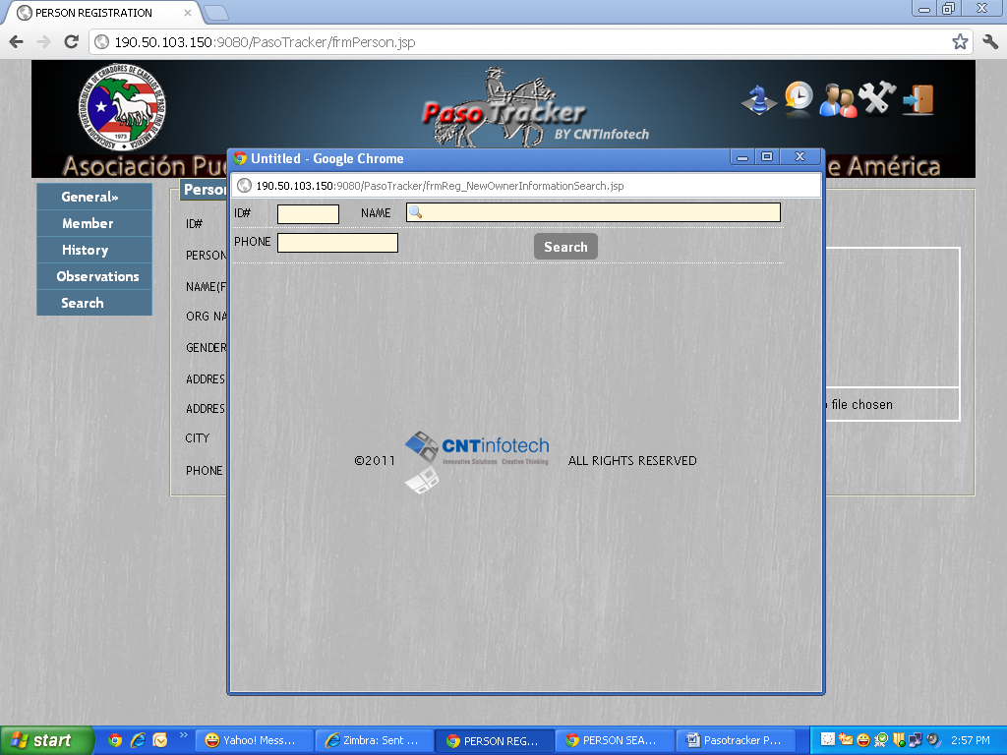
Issue 1: The Person search pop up should be entitled Person search.

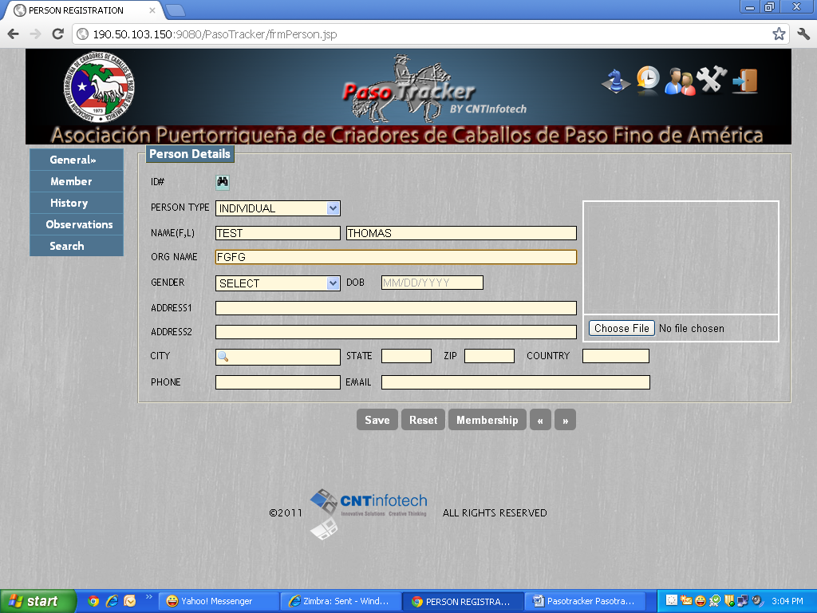
Issue 2: Why is it allowing me to enter an ORGANIZATION name when we have selected Person Type as Individual?

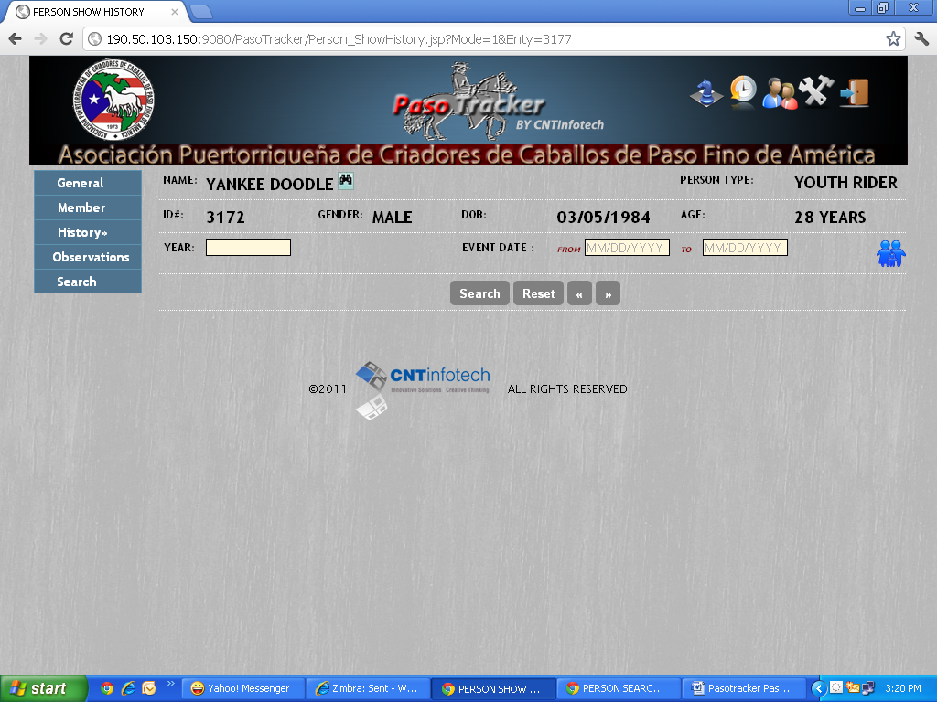
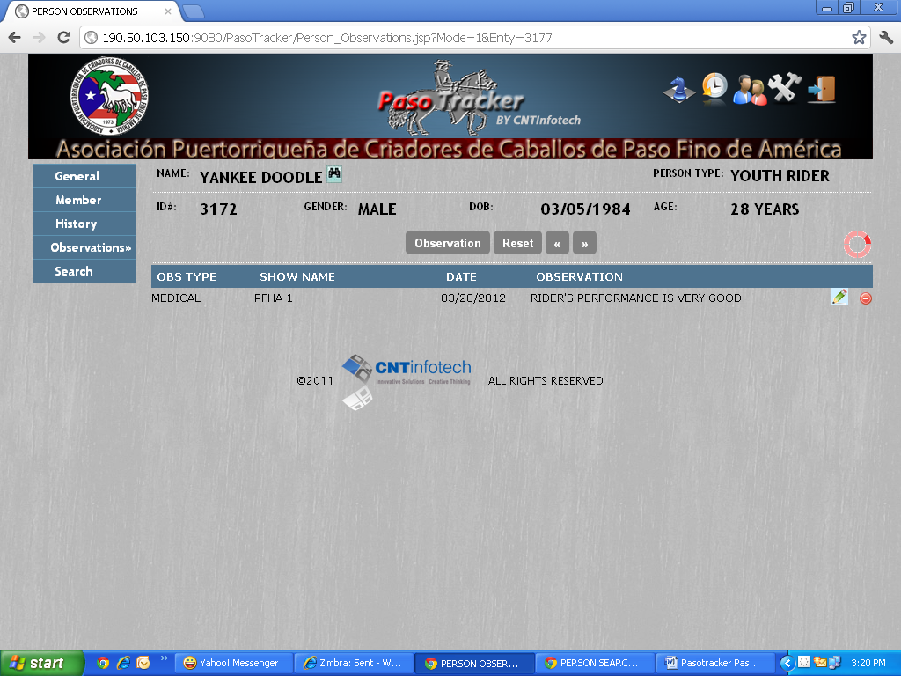
Issue 3: The member icon needs to appear consistently in both History and Observations Screen.

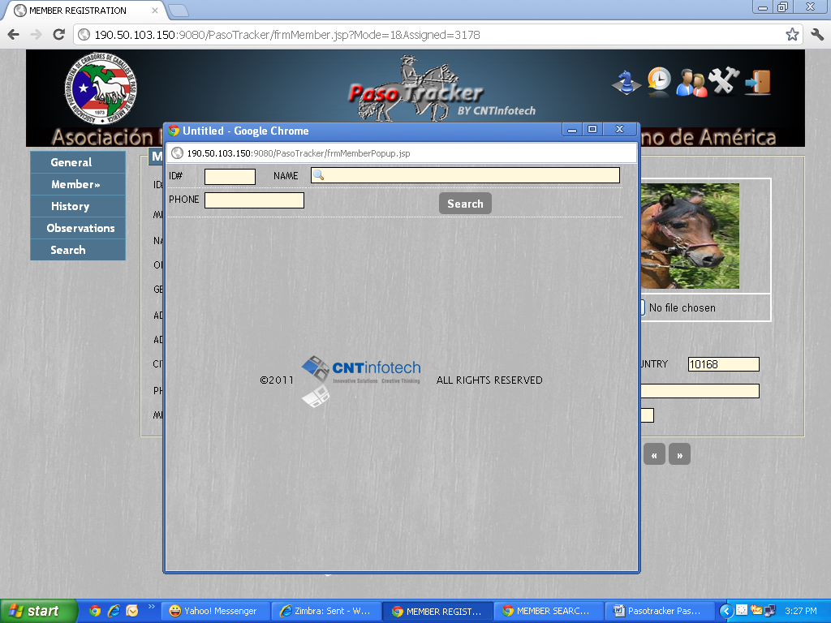
Issue 4: Member Search should be entitled MEMBER SEARCH.

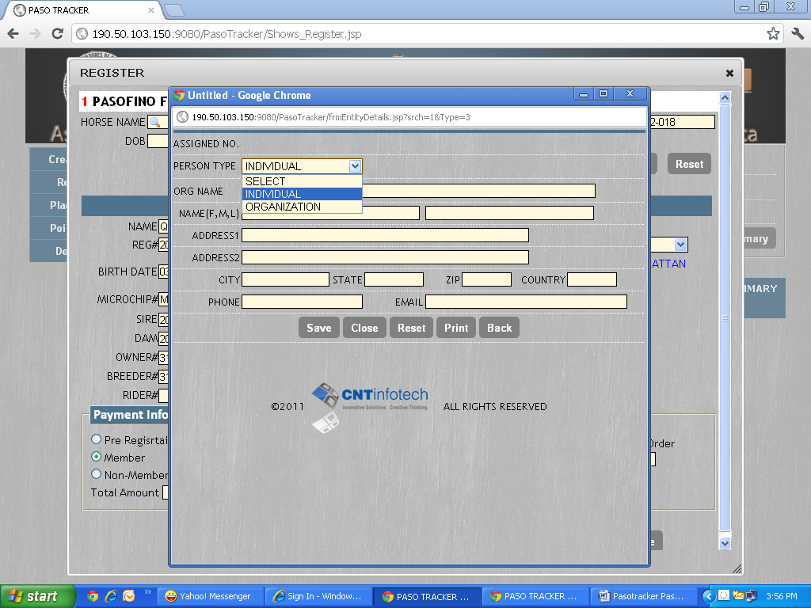
Issue 5: Youth Rider option should be available when we try to register a new rider in Shows.

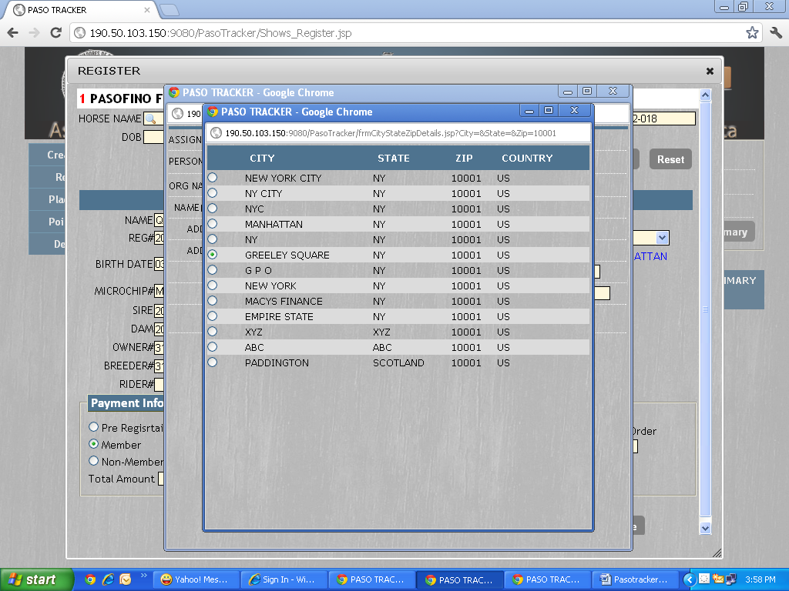
Issue 6: Unable to select city, state, zip and country record using zip code search.

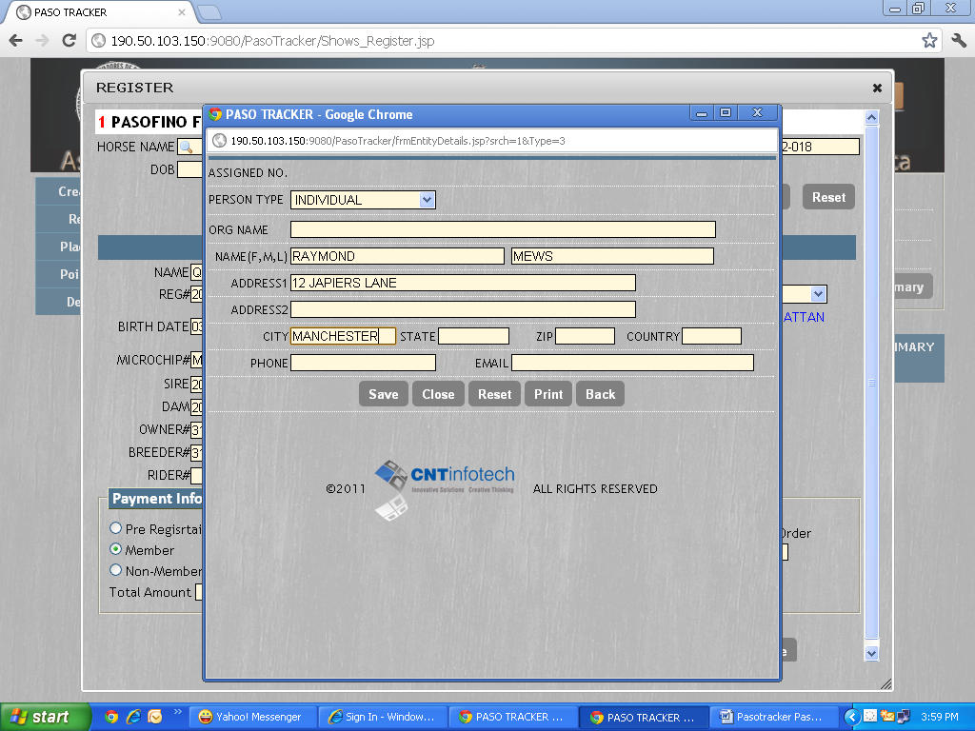
Issue 7: There is no partial search field available for city.

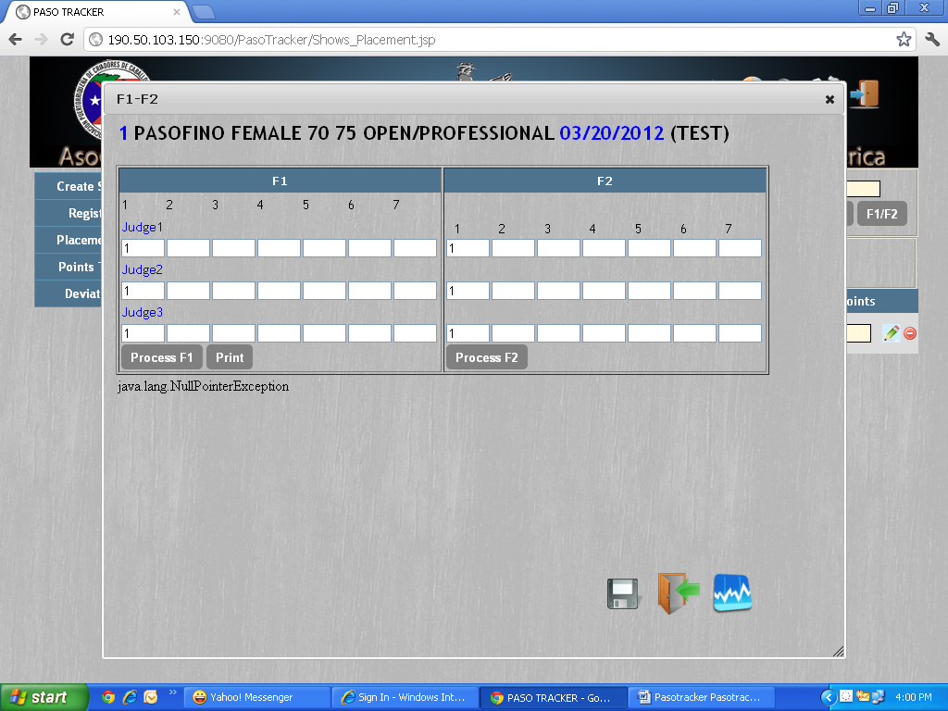
Issue 8: If I enter save twice ..i get java lang NullPointer Exception error message.

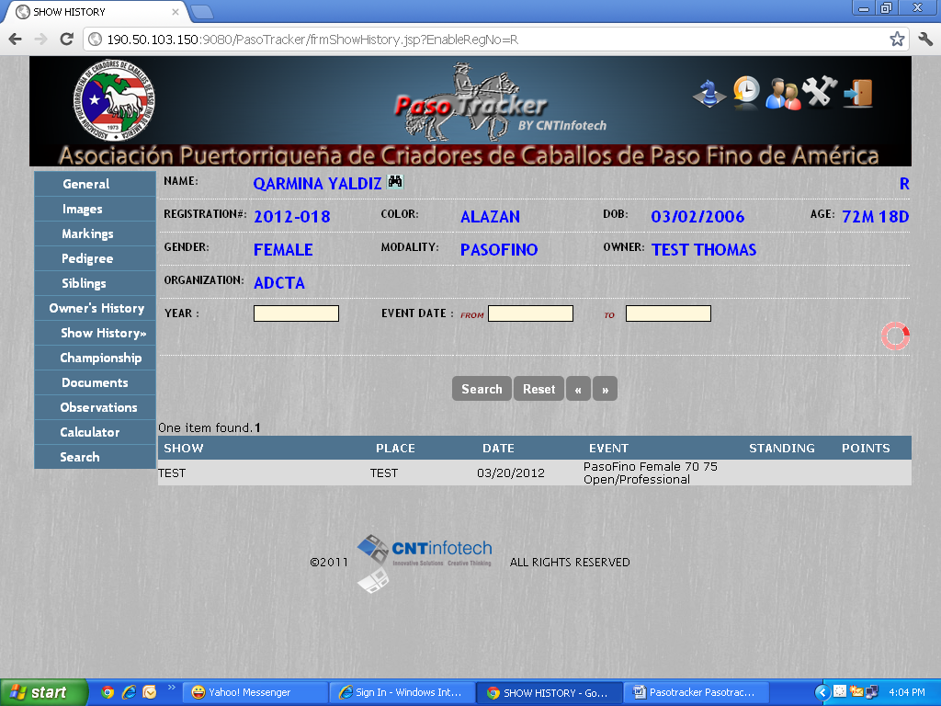
Issue 9: From and To Date fields should have MM/DD/YYYY in the background.

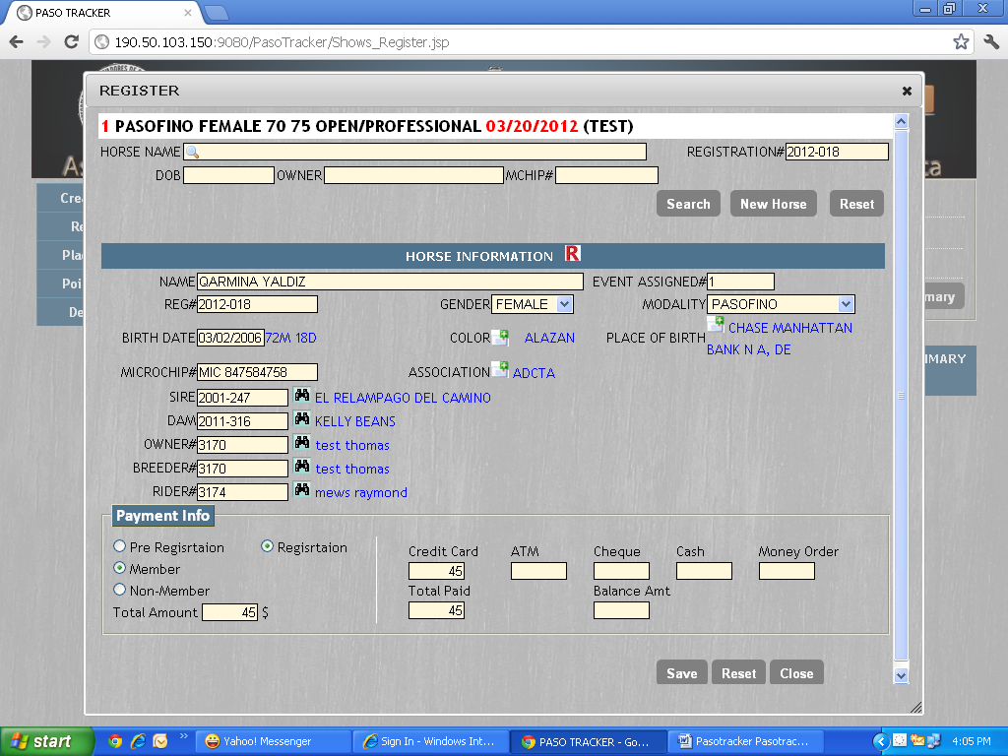
Issue 10: Pre- Registration and Registration spellings in the above screen needs to be rectified.

